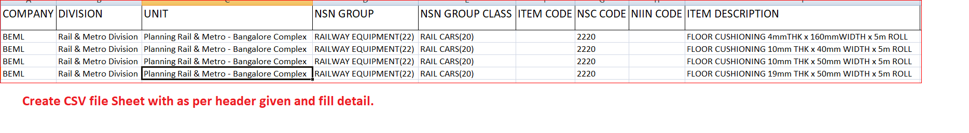

Step 1. Create CSV file with all given header or excel format.

Step 2. Upload CSV file on website with remove header file.

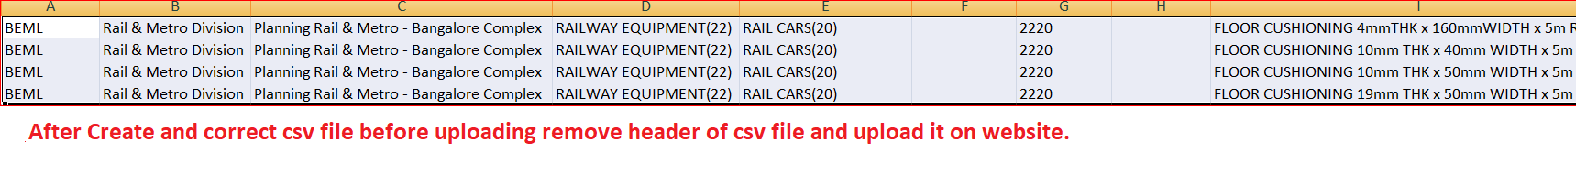

Note:- This images are demo for help you to upload csv file in correct way.

Please for header download excel sheet format above download icon in page.